**Web Programming Languages – Practice Work 3**

**Due date:** September 24, 11:59pm

In this practice work, you will create below todo list by using HTML, CSS and JQuery.

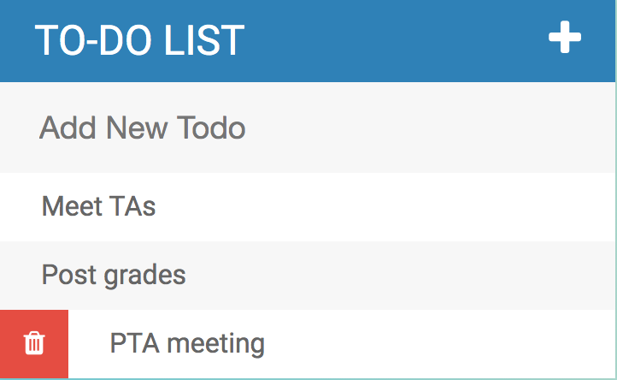

**Requirements:**

When user clicks on the + icon, it will toggle between showing and hiding the textbox which is used to insert a new item to the list.

When user focuses on the textbox, it will change the border color of the textbox (any color) and when user presses the *enter* key, it will add the item to the list.

When user hovers over any todo item, it will show delete button and when clicked on the delete button, will delete the item from the list.

When user clicks on the todo item, it will strike through the item and show it as completed.

*Source for icons:*

<link rel="stylesheet" type="text/css" href="https://cdnjs.cloudflare.com/ajax/libs/font-awesome/4.4.0/css/font-awesome.css">

<i class="fa fa-plus">

<i class="fa fa-trash"></i>

You can use different icons from a different source.

**Solution Hint:**

1. You can use below HTML code for your initial list.

<ul>

<li><span><i class="fa fa-trash"></i></span> Meet TAs</li>

<li><span><i class="fa fa-trash"></i></span> Post grades</li>

<li><span><i class="fa fa-trash"></i></span> PTA meeting</li>

</ul>

2. Define the width and height of the span element as 40px and initially hide it. Set display: inline-block to see effect of changing width and height for the element. Set background color as red, font color as white and text-align to center.

You don’t have to have exact same look, your work will be graded based on functionality but these settings will help you to have a similar output.

3. Define *mouseenter* event for li element (ul.on(“mouseenter”. “li”, function(){}) for showing the trash bin, and *mouseleave* for hiding the bin.

<https://api.jquery.com/mouseenter/#mouseenter-handler>

<https://api.jquery.com/mouseleave/#mouseleave-handler>

4. For actually hiding and showing the trash bin, you can use show() and hide() or fadeIn() and fadeOut().

$(this).find(“span”).show();

$(this) will give current li element.

**Submission:**

Zip your html, css, and js files together (PW3-yournetid.zip) and send through eLearning.

**Note:** If you are using external css and js, make sure you use relative path for file references.